**Safertek Backend Task 18 May 2024**

**N Krishna Chowdary Pathuri**

**2100032143**

I have created a database named **safertek18may** to store the data about the task.

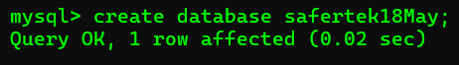

Create four tables.

* **customer_table** to store customer details.
* **product_table** to store product details.
* **orders_table** to store details about orders made by customers.
* **orderitems_table** to store details about items in each order.

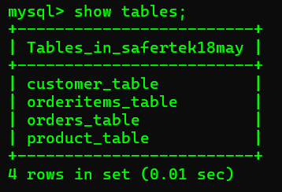

**--------------------------------------------------------------------------------------------------------------**

**customer_table:**

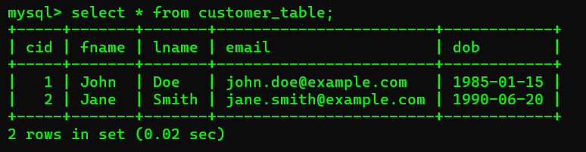

CREATE TABLE customer_table (

cid INT PRIMARY KEY,

fname VARCHAR(50),

lname VARCHAR(50),

email VARCHAR(100),

dob DATE

);

INSERT INTO customer_table VALUES (1, 'John', 'Doe', 'john.doe@example.com', '1985-01-15');

INSERT INTO customer_table VALUES (2, 'Jane', 'Smith', 'jane.smith@example.com', '1990-06-20');

**--------------------------------------------------------------------------------------------------------------**

**product_table**

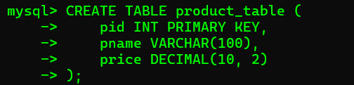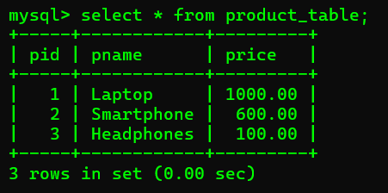

CREATE TABLE product_table (

pid INT PRIMARY KEY,

pname VARCHAR(100),

price DECIMAL(10, 2)

);

INSERT INTO product_table VALUES (1, 'Laptop', 1000);

INSERT INTO product_table VALUES (2, 'Smartphone', 600);

INSERT INTO product_table VALUES (3, 'Headphones', 100);  
**--------------------------------------------------------------------------------------------------------------**

**orders_table**

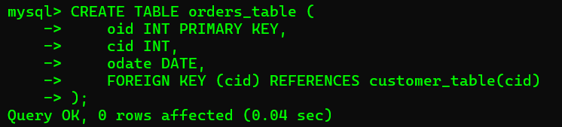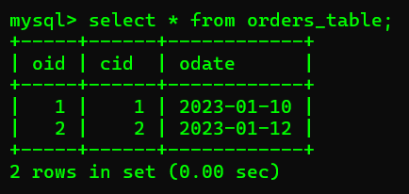

CREATE TABLE orders_table (

oid INT PRIMARY KEY,

cid INT,

odate DATE,

FOREIGN KEY (cid) REFERENCES customer_table(cid)

);

INSERT INTO orders_table VALUES (1, 1, '2023-01-10');

INSERT INTO orders_table VALUES (2, 2, '2023-01-12');

**--------------------------------------------------------------------------------------------------------------**

**orderitems_table**

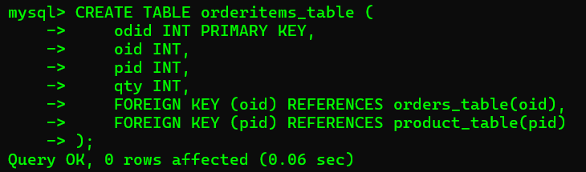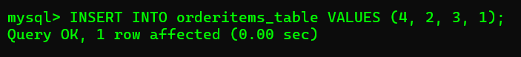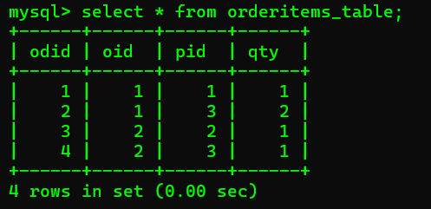

CREATE TABLE orderitems_table (

odid INT PRIMARY KEY,

oid INT,

pid INT,

qty INT,

FOREIGN KEY (oid) REFERENCES orders_table(oid),

FOREIGN KEY (pid) REFERENCES product_table(pid)

);

INSERT INTO orderitems_table VALUES (1, 1, 1, 1);

INSERT INTO orderitems_table VALUES (2, 1, 3, 2);

INSERT INTO orderitems_table VALUES (3, 2, 2, 1);

INSERT INTO orderitems_table VALUES (4, 2, 3, 1);

**Queries:**

**1. List all customers.**

SELECT * FROM customer_table;

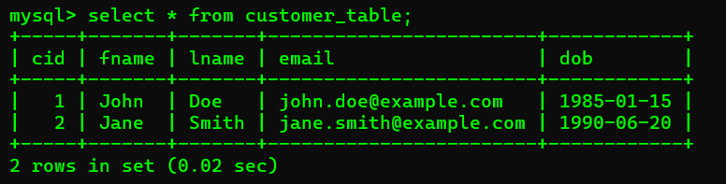

**--------------------------------------------------------------------------------------------------------------**

**2. Find all orders placed in January 2023.**

SELECT * FROM orders_table

WHERE odate BETWEEN '2023-01-01' AND '2023-01-31';

**--------------------------------------------------------------------------------------------------------------**

**3. Get the details of each order, including the customer name and email.**

SELECT o.oid, o.odate, c.fname, c.lname, c.email

FROM orders_table o

INNER JOIN customer_table c ON o.cid = c.cid;

**--------------------------------------------------------------------------------------------------------------**

**4. List the products purchased in a specific order (e.g., OrderID = 1).**

SELECT oi.oid, p.pname, oi.qty

FROM orderitems_table oi

INNER JOIN product_table p ON oi.pid = p.pid

WHERE oi.oid = 1;

**--------------------------------------------------------------------------------------------------------------**

**5. Calculate the total amount spent by each customer.**

SELECT c.cid, c.fname, c.lname, SUM(p.price * oi.qty) AS total_spent

FROM customer_table c

INNER JOIN orders_table o ON c.cid = o.cid

INNER JOIN orderitems_table oi ON o.oid = oi.oid

INNER JOIN product_table p ON oi.pid = p.pid

GROUP BY c.cid, c.fname, c.lname;

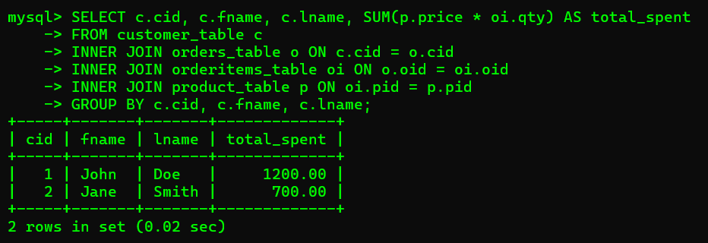

**--------------------------------------------------------------------------------------------------------------**

**6. Find the most popular product (the one that has been ordered the most).**

SELECT p.pname, SUM(oi.qty) AS total_ordered

FROM orderitems_table oi

INNER JOIN product_table p ON oi.pid = p.pid

GROUP BY p.pname

ORDER BY total_ordered DESC

LIMIT 1;

**--------------------------------------------------------------------------------------------------------------**

**7. Get the total number of orders and the total sales amount for each month in 2023.**

SELECT

EXTRACT(YEAR FROM o.odate) AS year,

EXTRACT(MONTH FROM o.odate) AS month,

COUNT(o.oid) AS total_orders,

SUM(p.price * oi.qty) AS total_sales

FROM orders_table o

INNER JOIN orderitems_table oi ON o.oid = oi.oid

INNER JOIN product_table p ON oi.pid = p.pid

WHERE EXTRACT(YEAR FROM o.odate) = 2023

GROUP BY year, month

ORDER BY year, month;

**--------------------------------------------------------------------------------------------------------------**

**8.Find customers who have spent more than $1000.**

SELECT c.cid, c.fname, c.lname, SUM(p.price * oi.qty) AS total_spent

FROM customer_table c

INNER JOIN orders_table o ON c.cid = o.cid

INNER JOIN orderitems_table oi ON o.oid = oi.oid

INNER JOIN product_table p ON oi.pid = p.pid

GROUP BY c.cid, c.fname, c.lname

HAVING SUM(p.price * oi.qty) > 1000;

